Ride With Me
Input/Output Analysis

Prepared by: Felix Ingabire (TL), Lombe Chileshe (SE), Li Yu Feng (SE)

Version 1.2
July 11, 2014

Document History and Distribution

Revision History

Revision # | Revision Date | Description of Change | Author
1.0 | 2014 07 15 | Initial Document | Felix Ingabire
1.1 | 2014 07 16 | Lecture Review | Li Yu Feng & Lombe
1.2 | 2014 07 11 | Final Document Release | Felix Ingabire

Definitions and Acronyms

Term | Definition
TO | Technical Overview
TL | Technical Lead
PM | Project Manager
ST | Software Tester
SA | System Administrator
SE | Software Engineer
IDE | Integrated Development Environment
JSON | JavaScript Object Notation) is a lightweight data-interchange format.
DBMS | Data Base Management System
Eclipse EE | Eclipse Enterprise Edition
SQL | Standard Query Language
JDK | Java Development Kit
HTML | Hyper Text Markup Language
CSS | Cascading Style Sheets
HTTP | Hyper Text Transfer Protocol

Audience:

Name | Role
Sebastian Alvarado | PM
Lombe Chileshe | SE
Li Yu Feng | SE
Nick | ST

INTRODUCTION

The system consists of 4 modules: Two Android applications, a server and an administrative website.

The purpose of this document is to analyze the input and output of the two Android applications. The first is the Passenger Application and the other is the Driver Application. The Server will integrate these 2 applications.

Passenger Application

Introduction
This application runs on a passenger’s phone. Here, we analyze the input and output for every process in the application.
- Register process
Input
1. Name: String [“Lombe Chileshe”]
2. Password: String [“123fghh”]
3. Confirm Password: String [“123fghh”]
4. Email: String [lombe.chileshe@gmail.com]
5. Phone: String [“+260975642543”]
6. Picture: Java Object
7: Address: String [“21, Jump Street”]
8. Credit Card No: String [“2345 124343 1223 1221”]

public class User{
private EditText email
private EditText password;
private EditText confirmPassword;
private EditText name;
private EditText PhoneNumber;
private EditText Address;
private EditText CCNo;
private Image YourPicture
}

Output
1. Registry accepted message: String [“You’ve been successfully registered”]
2. Login Page: Link [“Redirected to another page”]

if (password.equals(confirmPassword)){
Toast.makeText(getApplicationContext(),"SuccessfullySignedUp",Toast.LENGTH_SHORT).show();
}
else{
Toast.makeText(getApplicationContext(),"SignUpFailed.Passwords",Toast.LENGTH_LONG).show();
}
2. Login Process
Input
1. Username (which is the user’s email): String [“Lombe.chileshe@gmail.com”]
2. Password: String: [“abcd1234”]
public class User{
private EditText email
private EditText password;
}

Output
- Location: JSON data from the Google Locations API [“A point on a map”] 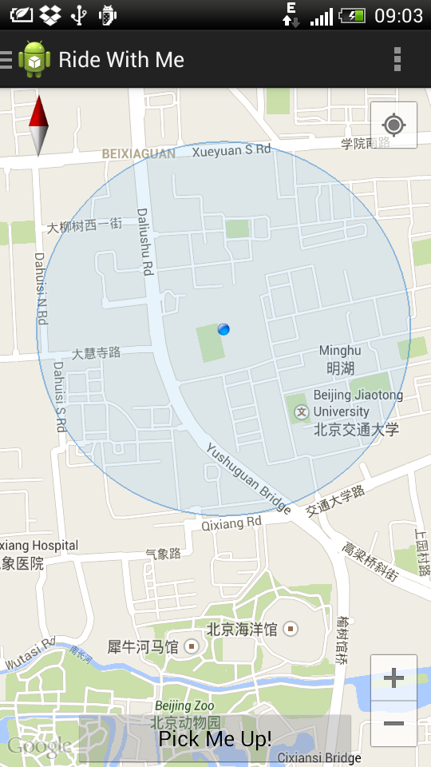
Figure 1.1: Showing a Map and a point on the map.

- Map: JSON data from the Google Maps API
$.getJSON( 'http://jquery-ui-map.googlecode.com/svn/trunk/demos/json/demo.json', function(data)

3. In The Case of Password or Username error, there will be an error message on the screen. : String [“Wrong Username or Password”]

public class PickMeUpFragment extends Activity
implements NavigationDrawerFragment.NavigationDrawerCallbacks {

GoogleMap map = ((MapFragment) getFragmentManager()
.findFragmentById(R.id.map2)).getMap();
map.getUiSettings().setMyLocationButtonEnabled(true);
mapHelper.getMapWithCurrentLocation (getApplicationContext (), map, 15);
}

3. Booking a ride Process
Input
1. User location: LatLng: [“LngLat 21.1232, 24. 123212”]
2. User Id/email: String [Lombe.chileshe@gmail.com] (will be transferred to the server: user doesn’t need to enter it.)
3. Destination: String [“San Litun”] (Program converts it to a LatLng variable and sends it to server)
public class BookARide extends Activity {

EditText yourCurrentLocation;
EditText yourDestination;
}

Output
(All received as JAVA object from the server)
After a while the list of driver bid will show up
Indicating
1. Driver Name: String [“John James”]
2. Time to arrival: String [“30 Minutes”]
3. Fee: String [“RMB 23”]
4. Driver Picture: Image [“picture of driver”]
5. Driver Rating : Rating Bar[“Number of Stars”]

public class ChooseYourDriver extends Activity {
private TextView DriverName;
private TextView ETA;
private TextView Fee;
private Image DriverPhoto;
private RatingBar DriverRating;
}

4. See Driver Details Process
Input
Request for More Details: Button
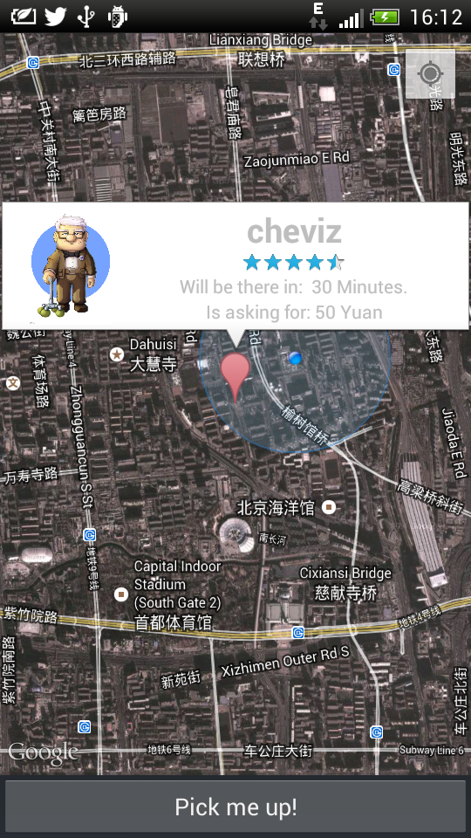

public class ChooseYourDriver extends Activity {
private Button getDriverDetails;
}

Output
(All received as JSON objects from the server)
1. Driver Rating: String [“Number of stars a driver has”]
2. Contact number: String [“1234445322”]
3. Car Type: String [“Toyota Corolla”]
4. Fee: String [“23RMB”]
5. Time to Arrive [“30 Minutes”]
6. Car Picture: Image: [“Picture of Car”]

public class DriversProfileWithCar extends Activity {
private TextView DriverRating;
private TextView ContactNumber;
private TextView CarType;
private TextView Fee;
private TextView ETA;
private Image DriverPhoto;
}
5. Choosing a Driver Process
Input
1. User Chooses a Driver: Button [“Choose Button”]
public class DriversProfileWithCar extends Activity {
private Button ChooseThisDriver;
}

Output
1. Confirmation Data from Server: JSON Object: String [“Booking Successful”]

6. Sending a reminder Process
Input
1. Request message: Button [“Hurry up Button”]

Output
Not Applicable.

7. Rating and View Fee Process
Input
- Driver Rating star number: Rating Control: [“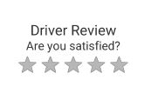”]

public class DriversProfileWithCar extends Activity {
private Button ChooseThisDriver;
}

Output
1. Confirmation Data from Server: JSON Object: String [“Review recieved”]

Driver application
Introduction
This application runs on a driver’s phone. Here, we analyze the input and output for every process in the application.
1. Login process
Input
1. Username/Email :( string) [abcd@gmail.com]
2. Password: (string) [“abc12345”,”123566”]
Public class driver extends Activity {
Private string username;
Private string password;
}

Output
- Location: JSON data from the Google Locations API [“A point on a map”]
[Latitude - Longitude:
38.706863,-90.298205]
[Lat: 38° 42' 24.7062"
Long: -90° 17' 53.5374"]

2. Look for Passengers button shows up: Button [“Look for Passengers”]
3. In The Case of Password or Username error, there will be an error message on the screen. : String [“Wrong Username or Password”]

public class LookForPassenger extends Activity
{
GoogleMap map = ((MapFragment) getFragmentManager()
findFragmentById(R.id.map2)).getMap();
map.getUiSettings().setMyLocationButtonEnabled(true);
mapHelper.getMapWithCurrentLocation(getApplicationContext(),map, 15);
}
2. Looking for Passenger Process
Input
- Request to the server: Button [“Look for Passenger”]
- Location of Driver: LatLng[“65.64664, 21.56545”]

Output
1. Location of Passengers: Json data (List <string>) [(“44, 23”), (“45, 23.1111”)]
2. Origin : LatLng String [“67,123”]
3. Destination LatLng (string) [“89,176”]
4. Distance: (string) [3KM]

3. Choosing a passenger and Bid Process
Input
- Time It will take the Driver : String [“20 minutes”]
- Fee for the Trip: String [“25 RMB”]

Output
1. Acceptance message or rejection message: JSON data (String) [“yes”]
*json data

4. Picking the passenger process
Input
- Sending information to the server telling that a passenger is already picked (button)[“picked”]
Output
- Map: JSON data [“image of a map”]
$.getJSON( 'http://jquery-ui-map.googlecode.com/svn/trunk/demos/json/demo.json', function(data)

5. Destination reached Confirmation
Input:
- Sending information to the server telling the system that the destination has been reached (Button) [“reached”]

Output
- Fee : String [“80 RMB”]

6. Review Customer and view Fee
Input
1. Passenger Rating star number: Rating Control:

public class PassengerReview extends Activity {
private Button BtnSubmitReview;
private RatingBar passengerRating;
}
Output
1. Confirmation Data from Server: JSON Object: String [“Review received”]
{
"Message": ′Review received′,
}

